Mission:
Engaging the community, industry & government to promote & advocate for Queensland’s evolving stormwater challenges
19 September 2022
Dear Member,

Stormwater Queensland will hold its Annual General Meeting (AGM) on Wednesday 19 October 2022 at 11:00 am via Zoom.

Stormwater Queensland is an Incorporated, not-for-profit association established in 1996. Stormwater Queensland aims to be the leading association for the promotion and advancement of stormwater management in Queensland.

All financial members of Stormwater Queensland are invited to nominate for either a position on the Executive Committee or as an Ordinary Committee member for the 2022-2023 year. Stormwater Queensland is seeking committee members who are eager and enthusiastic to advance the stormwater industry and who want to play an active role in setting the direction of the association and its activities. Participation on the committee is also of personal benefit, providing professional development and networking opportunities.

Nominees should take note of the following:
- Management Committee meetings are now held via Teams, currently on the third Wednesday of every month between 12:00 pm and 1:00 pm. Every month, sub-committee meetings are held from 11:00 am to 12:00 pm on the same day as the committee meetings.

- Committee members are expected to play an active role in association activities and will be required to undertake a specific role or task, including participation on a sub-committee. This will require effort outside of the management committee meetings.

- Should there be more than one nomination for an Executive Committee position (ie President, Vice President, Treasurer or Secretary) or more than the required number of management committee member nominations, the positions will be decided by a simple majority determined by ballot of the members present at the AGM. Nominees for all positions must include, with their nomination, a 100 word professional profile including a statement on what they believe they can add to the committee.

Nominations for the 2022-2023 Committee need to be completed and returned by 11:00 am on Wednesday 5 October 2022 to Stormwater Queensland via email to secretary@stormwaterqueensland.asn.au

If you have queries regarding participation on the Committee or the nomination process, please feel welcome to contact the Secretary as above.
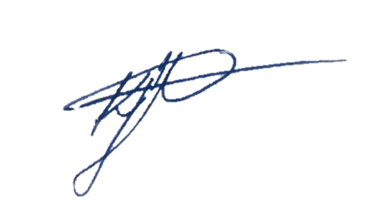
KATIE FLETCHER
President
Stormwater Queensland

