President’s Report
For presentation at Stormwater Queensland AGM 2022
The past year has been a busy one as Stormwater Queensland continued a busy calendar of technical events and saw a return of face-to-face events, awards and our conference.
Our webinars covered a diverse range of topics however, the highest attendance numbers are still coming from topics about stormwater quality. However, as webinars have a very low to negligible cost base, we have been able to diversify our topics to include drainage, integrated water management and mental health.
July saw our first in person event in quite some time! The panel session brought together a mixed crowd spanning experience level, industry and specialty to help us remember the past and look to the future, identifying the key issues of relevance to our membership. There will hopefully be additional panel events in the future to build off this success and engage different groups of people in the discussion.
This year’s state conference has been reimagined slightly and will take the form of our first Sustainability Summit. Hosted at QUT, this event aims to expand our typical program to include more current research, more panel discussions and a greater focus on sustainability and climate change. With a stellar line-up of speakers, this is an event not to miss.
Our advocacy team published position statements on WSUD and rainwater tanks.
The return of state awards saw submissions across all categories including the introduction of a new category for Early Professional of the Year. The inclusion of this new category aims to recognise the importance of our future leaders and to bring us in line with other associations. Award will be announced at the Sustainability Summit function.
To further recognise our early professionals, Stormwater Queensland revised our membership categories to include a Graduate category. This membership rate is a stepping-stone to full membership. We have also broadened our corporate membership categories with additional options for larger numbers of members.
Thank you to everyone who has served on the committee this year, including the many who contribute via our sub-committees. Your support is greatly appreciated and helps to ensure a healthy program of events and advocacy. For 2022/2023, I would hope to see an influx of new members to the committee to bring fresh ideas and enthusiasm and work collaboratively with our longer serving members. I would particularly invite early professionals and government members to join us to increase the diversity of thought and to help ensure the longevity of our association.
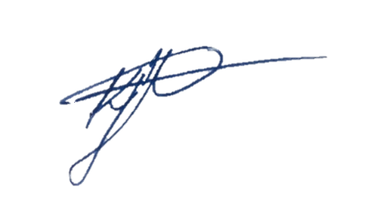
Katie Fletcher
President
Stormwater Queensland

