NOTICE
2023
ANNUAL GENERAL MEETING

Notice is hereby given that Stormwater Queensland will hold its Annual General Meeting as follows:

Wednesday 4 October 2023
11.00 am – 11.30 am
Via Zoom
https://us02web.zoom.us/meeting/81359239036

The agenda, and its supporting papers, are attached. These documents are also published on the Association’s website.

Members unable to attend the meeting may exercise their right to vote via a Proxy. Proxies must be issued on the form attached. All members voting and issuing proxies must be financial members of Stormwater Queensland.
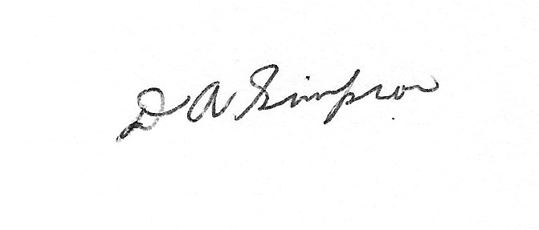
DAVID SIMPSON
Secretary
Stormwater Queensland

STORMWATER QUEENSLAND
2023 ANNUAL GENERAL MEETING
NOMINATION OF A PROXY
FOR AND ON BEHALF OF A FINANCIAL MEMBER

Forms nominating a Proxy must be deposited with the Secretary via email to admin@stormwaterqueensland.asn.au, prior to the commencement of the meeting.

I,………………………………………………………………………………(full name)

of……………………………………………………….…………………(organisation)

being a member of the abovementioned Association hereby appoint:

…………………………………………………………………… (name of member)

of………………………………………………….………………………(organisation)

as my Proxy to vote for me on my behalf at the Annual General Meeting of the Association, to be held on 4 October 2023, and at any adjournment thereof.

Signed this............................................/…………………………….........../2023

……………………………………............................ (signature)

